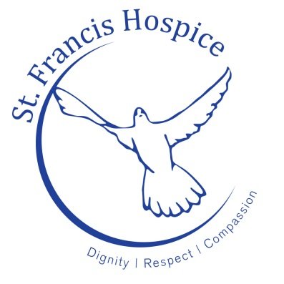

St. Francis Hospice Dublin is in the process of establishing a Clinical Supervision Programme for Clinical Nurse Specialists within St. Francis Hospice Services.

We wish to invite expressions of interests from parties interested in the implementation of this initiative. The suitable candidate will be expected to deliver clinical supervision on a weekly basis to the Clinical Nurse Specialists within St. Francis Hospice Dublin. This is a two year initiative, subject to evaluation after a 12 month period.

Please forward expressions of interest to Sr. Margaret Cashman, Director of Nursing before close of business on 23rd August 2017.

Informal enquiries to Dr Kevin Connaire, Director of Education.

St Francis Hospice Dublin

Raheny Hospice Blanchardstown Hospice
Station Road Blanchardstown
Raheny, Dublin 5 Dublin 15
D05 E392 D15 DE98

(01) 832 7535 (01) 829 4000

